How to download AdminLTE3 Template?

* First, go to browser to find AdminLTE3 Dashboard.
* Click the following link <https://adminlte.io/themes/dev/AdminLTE/index3.html>. And, you see the AdminLTE3 Dashboard like this.

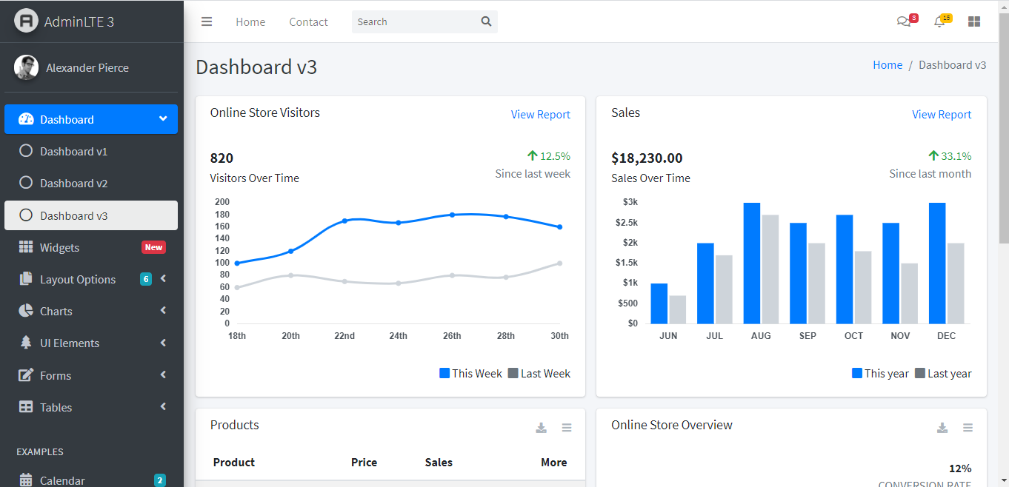

* To download **AdminLTE3**, you need to click **“Documentation Button”** from the left menu of Dashboard that I marked.

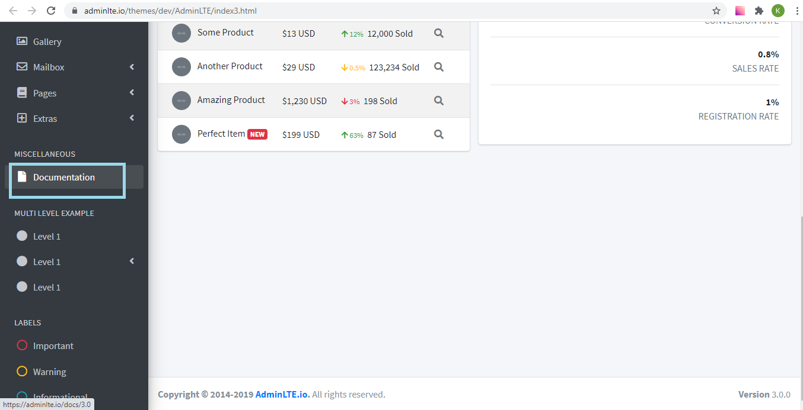

* Now, you see the introduction and download for AdminLTE3. There are several ways to download. I will show you how to download from **Github.**
* Click the [latest release](https://github.com/ColorlibHQ/AdminLTE/releases) link to download from Github.

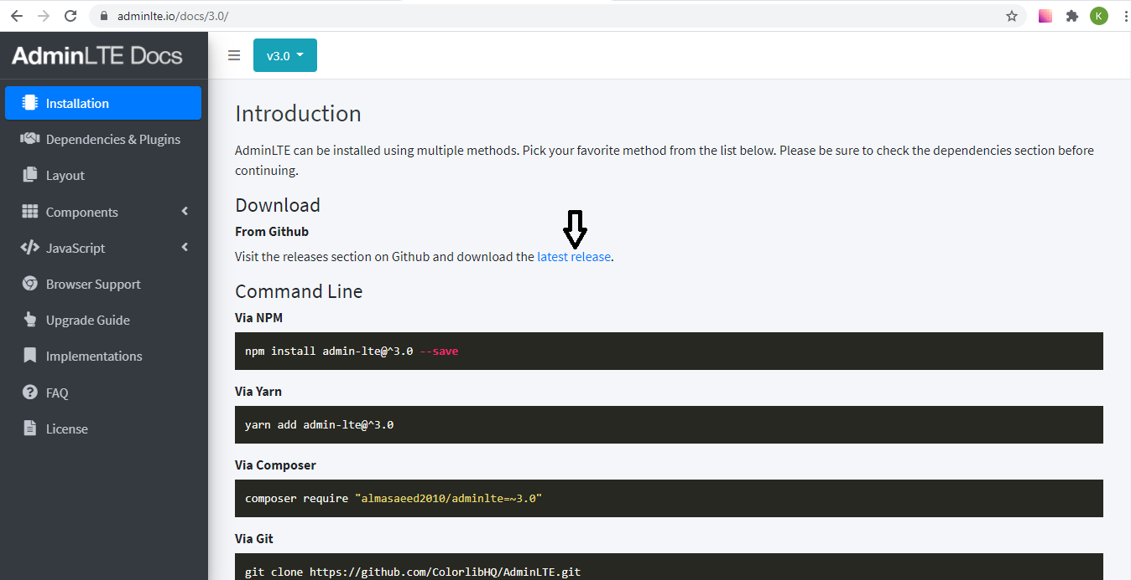

* If you don’t have github account, need to create github account first. And, download source code (zip file).

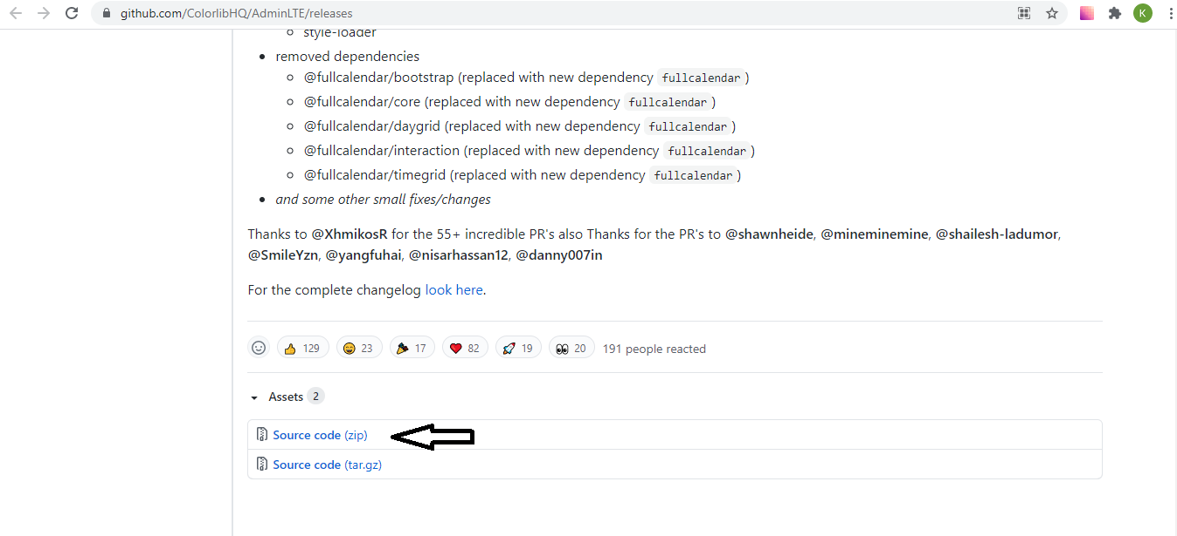

* Now, you extract **AdminLTE-3.1.0** zip file in your pc and you can use the **AdminLTE3 Dashboard**.